**HOME SECURITY SYSTEM**

**A**

**Project Exhibition -1**

Submitted in partial fulfillment for the award of the degree of

**Bachelor of Technology**

**In**

**ECE (AI & CYBERNETICS)**

Submitted to

**VIT BHOPAL UNIVERSITY (M.P.)**



**Submitted by**

**ANAGHA CHALLA (21BAC1011)**

Under the Supervision of

Dr. Amit Kumar Singh

**SCHOOL OF ELECTRICAL & ELECTRONICS ENGINEERING**

**VIT BHOPAL UNIVERSITY**

**BHOPAL (M.P.)-466114**

**OCTOBER-22**



**VIT BHOPAL UNIVERSITY BHOPAL (M.P.) 466114**

SCHOOL OF ELECTRICAL & ELECTRONICS ENGG.

**CANDIDATE’S DECLARATION**

I hereby declare that the Dissertation entitled “HOME SECURITY SYSTEM" is my own work conducted under the supervision of Amit, Designation, Name of Department at VIT University, Bhopal.

I further declare that to the best of my knowledge this report does not contain any part of work that has been submitted for the award of any degree either in this university or in other university / Deemed University without proper citation.

Anjali .S. Kumari (21BAC10028)

Anagha challa (21BAC10011)

Andrew Debbarma(21BAC10024)

Harsh Tripathi (21BAC10016)

This is to certify that the above statement made by the candidates is correct to the best of my knowledge.

Date: 3rdOctober, 2022

Guide Name Dr. Amit Kumar Singh

Designation Assistant Professor Junior

--------------------------------------------------------

Digital Signature of Guide



**VIT UNIVERSITY BHOPAL (M.P.) – 466114**

SCHOOL OF ELECTRICAL & ELECTRONICS ENGG.

**CERTIFICATE**

This is to certify that the work embodied in this Project Exhibition -1 report entitled **“HOME SECURITY SYSTEM”** has been satisfactorily completed by **Anjali S. Kumari (21BAC10028) , Anagha Challa (21BAC10011) , Andrew Debbarma (21BAC10024) , Harsh Tripathi (21BAC10016)** in the School of Electrical & Electronics Engineering of at VIT University, Bhopal. This work is a bonafide piece of work, carried out under our guidance in the School of Electrical & Electronics Engineering for the partial fulfilment of the degree of Bachelor of Technology.

**Dr. Amit Kumar Singh**

**(Assistant Professor Junior)**

Forwarded by Approved by

**Dr. Soumitra K Nayak Dr. Debashish Adhikari**

**Program Chair - B.Tech ECE (AI & Cybernetics) Professor & Dean - SEEE**

**ACKNOWLEDGEMENT**

First and foremost, we would like to thank the Lord Almighty for His presence and immense blessings throughout the project work.

We wish to express our heartfelt gratitude to Dr Debashish Adhikari , Head of the Department, School of Electrical & Electronics and Dr. Soumitra K Nayak, Program Chair - B.Tech ECE (AI & Cybernetics) Engineering for much of his valuable support encouragement in carrying out this work.

We would like to thank our internal guide Mr. Amit Kumar Singh, for continually guiding and actively participating in my project, giving valuable suggestions to complete the project work.

We would like to thank all the technical and teaching staff of the School of Electrical & Electronics Engineering, who extended directly or indirectly all support.

Last, but not least, we are deeply indebted to our parents who have been the greatest support while we worked day and night for the project to make it a success.

**ABSTRACT**

Home security system is highly preferable not only for home but also anywhere security issues are needed. This security is included for Home/ Bank/ Office and for the purpose of safety; everybody wants to take proper measures to prevent intrusion. Now days, intruder can take advantages to take any illegal works and can violent any important security issues. Keypad locked system is essential for securing any home or institutions. In this paper, we present the design and development of affordable cost and proper power consumption with password protected home security system.

**Executive Summary**

**Home Security System**

Safety and security of any living or working place is one of the most primary concerns. The concept of home automation and its safety has been around since late 1970s. But nowdays as the number of crimes are increasing every day, there has to be something that will keep us safe. We are all aware of the high end security systems present in the market but they are not easily available to everyone.

This project is based on the Security system using Keypad, Arduino Uno, and Servo motor which are not too expensive  
  
 We therefore intend to provide a solution by constructing a cost-efficient electronic system that has the capability of sensing the presence of the intruders and alerting the owner about the intrusion.

**LIST OF ABBREVIATIONS**

D – Digital pin of arduino

+ve – positive

-ve – negative

Grnd – ground

Col. – column

SDA- Serial Data Pin

SCL- Serial CLO Pin

PSWRD - Password

**LIST OF FIGURES AND GRAPHS**

|  |  |  |
| --- | --- | --- |
| **FIGURE NO.** | **TITLE** | **PAGE NO.** |
| 1 | Figure 1- Components | 3 |
| 2 | Figure 2- Circuit Diagram | 5 |
| 3 | Figure 3 –Implementation of Circuit | 8 |

**TABLE OF CONTENTS**

|  |  |  |
| --- | --- | --- |
| **Chapter no.** | **Title** | **Page no.** |
|  | Abstract  List of Abbreviations  List of Figures and Graphs | **v**  **Vii**  **viii** |
| **Chapter 1** | **PROJECT DESCRIPTION AND OUTLINE** Introduction 1.2 Motivation for the work  1.3 Problem Statement  1.4 Objective of the work  1.5 Methodology | **1-2** |
| **Chapter 2** | **LITERATURE REVIEW**  2.1 Table of research work | **3-4** |
| **Chapter 3** | **REQUIREMENT ARTIFACTS**  3.1 Description of hardware  3.2 Hardware fig. | **5-7** |
| **Chapter 4** | **DESIGN METHODOLOGY**  4.1 Introduction of circuit  4.2 Circuit connection explanation  4.3 Working | **8** |
| **Chapter 5** | **CODE**  5.1Source code | **9-13** |
| **Chapter 6** | **RESULT AND DISCUSSION**  6.1 Implementation  6.2 Conclusion  6.3 Future scope  6.4 Advantages    6.5 Disadvantages | **14- 15** |
|  | References | **16** |

**Chapter 1**

**PROJECT DESCRIPTION AND OUTLINE**

**Introduction**

Science and technology have advanced our life in many ways. It facilitates the process of industrialization as well as modernization of the world. It has blessed us with many sophisticated devices by facilitating our life. Password based security system is one of the modern electronic lock systemWe have designed an interesting and cheap home security system. This Gadget helps you to protect your house from thieves. In this project we are going to use an Arduino Uno R3 Board, keypad, LCD and some other components. This Project can be powered with U.S.B of your computer. When an intruder is detected, it activates a siren and.

**Motivation**

The need for home security alarm systems nowadays is a serious demand. As the number of crimes are increasing every day, there has to be something that will keep us safe.

The concept of home automation and its safety has been around since late 1970s. But during the course of time with the advancement of technology, our expectation from home has changed a lot and so have the idea of home automation and its security systems. If we look at different home automation systems over time, they have always tried to provide efficient, convenient and safe ways for home inhabitants to access their homes.

**Problem statement**

Humans have invented locks since ancient times, to use them to protect their privacy and personal belongings. they are constantly evolving over the ages for better protection. But the problem is that locking the door these days is not safe and can be easily bypassed. Our doors can be forgotten, and this is a common occurrence for most people. Locks are trying these days to depends on technology by using a code or phone or by card to make our things safer. But there are limits, which are the lack of features to be combined in one place. also, the lack of high-security features. To solve this problem, we need to combine all the modern security features into one lock as well as monitoring features. Thus, we have high security, comfortable opening, and closing systems, and features that help us easier and faster, all requirements do not conflict and help to make our homes safer than before.

**Objective**

The objective of this project is to design a cost -efficient  wireless communication link to monitor our home and to provide an easy access without compromising security.

**Methodology**

* On entering the wrong password through a 4*3 keypad, it will send us an alert on the phone also the buzzer starts beeping.
* On entering the right password, it will send us a confirmation message that the door has opened.
* Door opening and closing message will get displayed on the I2c LCD screen
* Also the servo motor which represents door in our project would start moving whenever we enter a correct password.
* The alert message would be sent to the phone through the bluetooth device.

**CHAPTER-2**

**LITERATURE REVIEW**

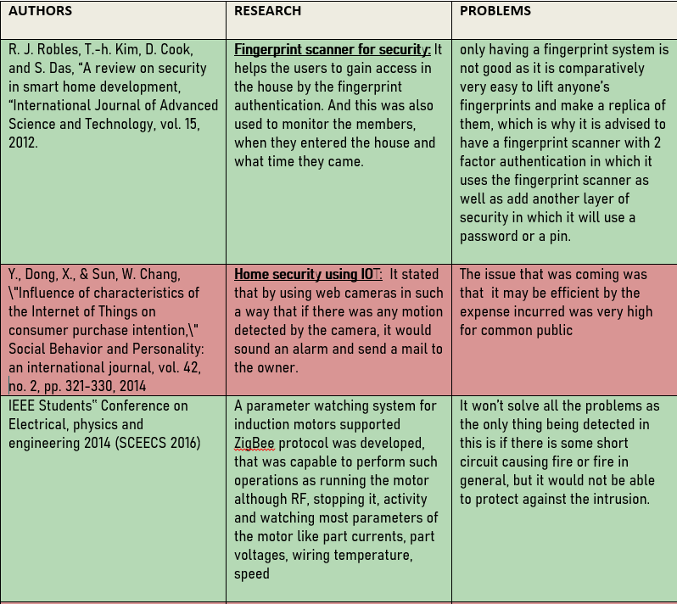 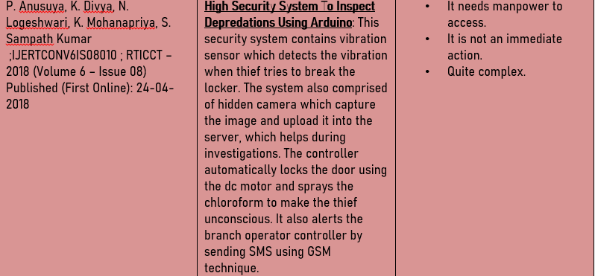 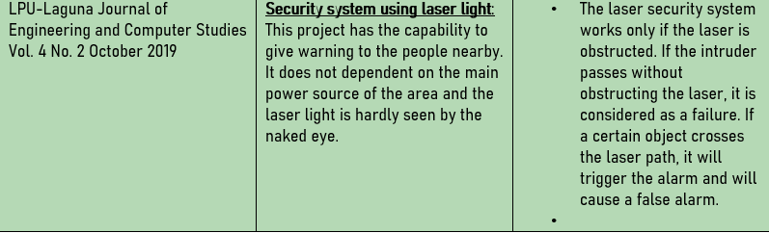 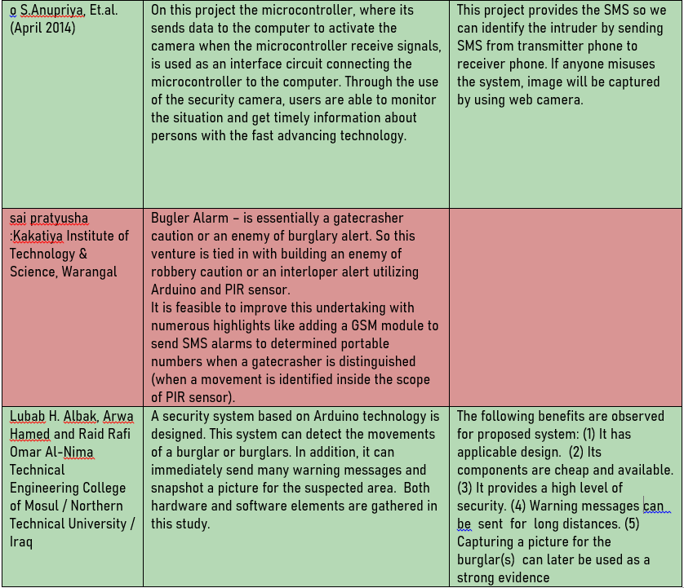

**CHAPTER-3**

**REQUIREMENT ARTIFACTS**

**Arduino UNO**:

It is a microcontroller board based on the ATmega328P. It has 14 digital input/output pins (of which 6 can be used as PWM outputs), 6analog inputs, a 16 MHz ceramic resonator, a USB connection, a power jack, an ICSP header, and a reset button. It contains everything needed to support the microcontroller; simply connect it to a computer with a USB cable or power it with an AC-to-DC adapter or battery to get started. The ATmega328P also features 1kb of EEPROM, a memory that is not erased when powered off.

**Servo motor**:

A Servo Motor is a small device that has an output shaft. This shaft can be positioned to specific angular positions by sending the servo a coded signal. As long as the coded signal exists on the input line, the servo will maintain the angular position of the shaft. If the coded signal changes, the angular position of the shaft changes. In practice, servos are used in radio-controlled airplanes to position control surfaces like the elevators and rudders. They are also used in radio-controlled cars, puppets, and of course, robots.

**4*3 keypad**:

The working principle is very simple. Pressing a button shorts one of the row lines to one of the column lines, allowing current to flow between them. For example, when key ‘4’ is pressed, column 1 and row 2 are shorted. A microcontroller can scan these lines for a button-pressed state. To do this, it follows below procedure.

1. Microcontroller sets all the column and row lines to input.
2. Then, it picks a row and sets it HIGH.
3. After that, it checks the column lines one at a time.
4. If the column connection stays LOW, the button on the row has not been pressed.
5. If it goes HIGH, the microcontroller knows which row was set HIGH, and which column was detected HIGH when checked.

Finally, it knows which button was pressed that corresponds to detected row & column.

**Buzzer:**

An arduino buzzer is also called a piezo buzzer. It is basically a tiny speaker that you can connect directly to an Arduino. The buzzer produces sound based the on the reverse of the piezoelectric effect. Piezo electricity is an effect where certain crystals will change shape when you apply electricity to them.. The buzzer produces the same noisy sound irrespective of the voltage variation applied to it. It consists of piezo crystals between two conductors. When a potential is applied across these crystals, they push on one conductor and pull on the other. This, push and pull action, results in a sound wave. Most buzzers produce sound in the range of 2 to 4 kHz.

**L2C LCD:**

Each I2C bus consists of two signals: SCL and SDA. SCL is the clock signal, and SDA is the data signal. The clock signal is always generated by the current bus master; some slave devices may force the clock low at times to delay the master sending more data (or to require more time to prepare data before the master attempts to clock it out). This is called “clock stretching” and is described on the protocol page**.**

**Bluetooth module:**

HC-05 is a Bluetooth module which can communicate in two way. Which means, It is full-duplex. We can use it with most micro controllers. Because it operates Serial Port Protocol (SSP). The module communicate with the help of USART (Universal Synchronous/Asynchronous Receiver/Transmitter ) at the baud rate of 9600 and it also support other baud rate. So we can interface this module with any microcontroller which supports USART. The HC-05 can operate in two modes. One is Data mode and other is AT command mode. When the enable pin is "LOW" the HC-05 is in Data Mode. If that pin set as "HIGH" the module is in AT command mode.

**COMPONENTS** **FIG. (1)**

|  |  |
| --- | --- |
| ARDUINO UNO |  |
| 4*3 KEYPAD |  |
| BUZZER |  |
| SERVO MOTOR |  |
| LCD I2C |  |

**CHAPTER – 4**

**DESIGN METHODOLOGY**

In this project, we will learn how to make the Home Security System Using Arduino , Keypad and other components. As thefts are increasing day by day security is becoming a major concern nowadays. So a digital code lock can secure your home or locker easily. It will open your door only when the right password is entered.

The circuit of this project is very simple which contains Arduino, keypad module, buzzer, Servo Motor, and LCD. Arduino controls the complete processes like taking a password from the keypad module, comparing passwords, driving buzzer, rotating servo motor, and sending status to the LCD display. The keypad is used for taking the password. The buzzer is used for indications. Servo motor is used for opening the gate while rotating and LCD is used for displaying status or messages on it.

**.**

**Step 1: Connecting 4*3 Keypad**

First of all, we will make a connection to the 4×3 Keypad. For connecting the keypad with the Arduino we are using digital pins D2 to D8. Connect all 3pins of col. Of keypad to D2, D3, D4 and row pins to D5, D6, D7, and D8 of arduino.

**Step 2: Connecting Servo motor**

Connect the grnd of servo to grnd of arduino, VCC to VCC of arduino , the o/p pin to D9 of arduino

**Step 4: Connect Buzzer**

Connect the +ve terminal of the buzzer to D9 of arduino as it’s the o/p pin and grnd the –ve terminal.

**Step 3: Connecting L.C.D**

To wire your LCD screen to your Arduino, connect the following pins:

LCD SDA pin to SDA pin of arduino

LCD SCL pin to SCL pin of arduino

LCD VCC pin to VCC pin of arduino

LCD grnd pin to grnd of arduino

**Step 4: Programming Arduino:**

1. Download Arduino IDE 1.0.6 from https://www.arduino.cc/en/main/software.

2. Connect Your Arduino to your computer using USB Cable.

3. Open Arduino IDE, choose your correct board from Tools--Boards

4. Choose Your Correct Port from Tools--Serial Port

6. Write the code of the project

7. Compile the code and upload the code to arduino board

8. Finally, then you can enter the correct pswrd and then the motor would rotate also LCD would display pswrd accepted.

**WORKING**

In this project, we have defined the default password “1234” in the Arduino. You can change it via coding. When we enter a password, it will match it with the password stored in the Arduino. If it is correct, then it will show ‘PASSWORD ACCEPTED’ and then rotate the servo motor to 180 doors as the door is opened. It will then give 5 seconds time for entering via the door.

If the password is wrong, then it will show ‘Code Incorrect, Go Away’. The buzzer will also beep once when any key is pressed.

**CIRCUIT DIAGRAM (Fig2)**

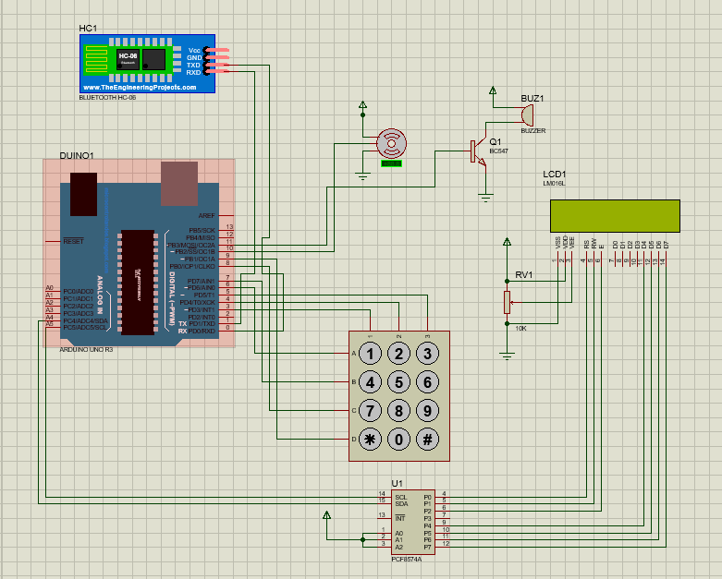

**CHAPTER – 5**

**SOURCE CODE**

#include <LiquidCrystal_I2C.h>

#include <Keypad.h>

#include <SoftwareSerial.h>

#include <Servo.h>

SoftwareSerial BTserial(8,12 ); // SoftwareSerial BTserial(Rx, Tx)

LiquidCrystal_I2C lcd(0x27, 16, 2);

Servo sg90;

constexpr uint8_t servoPin = 9;

constexpr uint8_t buzzerPin = 13;

char initial_password[4] = {'1', '2', '3', '4'}; // Variable to store initial password

char password[4]; // Variable to store users password

boolean NormalMode = true; // boolean to change modes

char key_pressed = 0; // Variable to store incoming keys

uint8_t i = 0; // Variable used for counter

const byte rows = 4;

const byte columns = 3;

char hexaKeys[rows][columns] = {

{'1', '2', '3'},

{'4', '5', '6'},

{'7', '8', '9'},

{'*', '0', '#'}

};

byte row_pins[rows] = {11, 7, 6, 5};

byte column_pins[columns] = {4, 3, 2};

Keypad keypad_key = Keypad( makeKeymap(hexaKeys), row_pins, column_pins, rows, columns);

void setup() {

// Arduino Pin configuration

pinMode(buzzerPin, OUTPUT);

sg90.attach(servoPin); //Declare pin 8 for servo

sg90.write(0); // Set initial position at 0 degrees

lcd.init(); // LCD screen

lcd.backlight();

// Arduino communicates with SIM900 GSM shield at a baud rate of 19200

// Make sure that corresponds to the baud rate of your module

BTserial.begin(9800);

}

void loop() {

if (NormalMode == false){

BTserial.print("Someone is trying to unlock the door");

}

else(NormalMode == true) ;{

key_pressed = keypad_key.getKey(); // Storing keys

if (key_pressed)

{

password[i++] = key_pressed; // Storing in password variable

lcd.print("*");

}

if (i == 4) // If 4 keys are completed

{

delay(200);

if (!(strncmp(password, initial_password, 4))) // If password is matched

{

lcd.clear();

lcd.print("Pass Accepted");

BTserial.print("\nDoor Opened \nIf it was't you, then there was an intrusion.");

sg90.write(90); // Door Opened

delay(5000);

sg90.write(0); // Door Closed

lcd.clear();

i = 0;

BTserial.print("\nDoor has been opened");

delay(2000);

}

else // If password is not matched

{

lcd.clear();

lcd.print("\nWrong Password");

digitalWrite(buzzerPin, HIGH);

delay(3000);

digitalWrite(buzzerPin, LOW);

lcd.clear();

i = 0;

BTserial.print("\nSomeone is trying to open the door");

delay(2000);

lcd.print("\nClosed");

delay(5000);

lcd.clear();

}

}

}

}

**CHAPTER – 6**

**RESULT AND DISSCUSSION**

**IMPLEMENTATION-**

**1) When password is correct and door is opened**

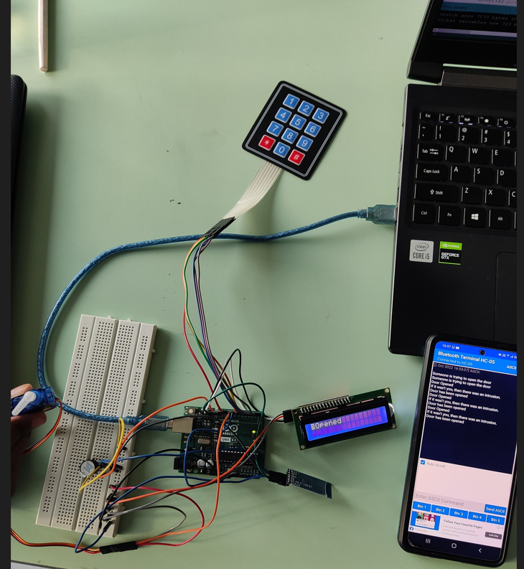

**(Fig3)**

**2) When password is incorrect and door is closed**

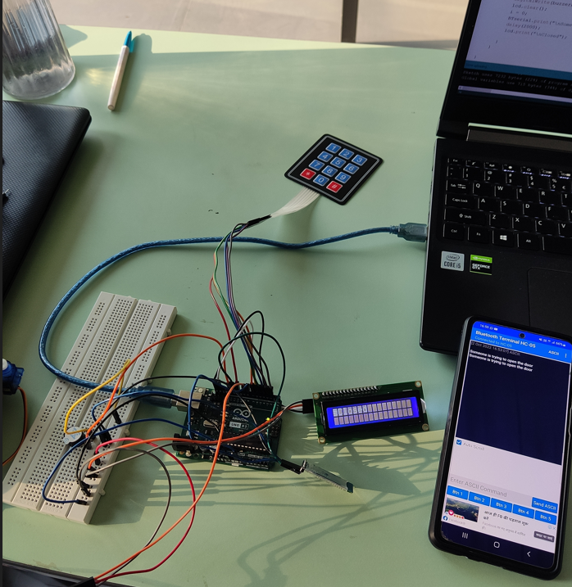

**(Fig4)**

**CONCLUSION-**

Every innovative work is started with a view to attaining a specific motto. Our main goal was to make such a type of lock which will provide highest security with the sacrifice of little cost. In this regard our project is an attempt to design and implement password protected electronic lock using Arduino.

Manually entered password and unlocks the lock when the correct password is inserted. The security system available in present market is too costly to use. Our project is a prototype which enables one how to make a password protected lock, which ensures highest security that can be made at a very low cost. This prototype is also reliable and user friendly.

**FUTURE SCOPE**

Various novelty and modification can be performed in our project. We can make the locking system more secured by adding more stage .We can use card authorization system in which card will be scanned first then password will be checked later. We can use another technique called biometrics. Biometrics may be a more prominent and a recognized means of positive identification. Their use may enhance security. Some new technologies such as fingerprint scanning, retinal scanning and iris scanning, and voiceprint identification also can be inserted. We can interface GSM modem which will send sms if invalid attempt is made to open.

**ADVANTAGES**

• The given system is handy and portable, and thus can be easily carried from one place to another.

• The circuitry is not that complicated and thus can be easily troubleshooted.

• The given system sets off a powerful buzzer, and also gives alert SMS.

**DISADVANTAGES**

•The given alarm system determines the presence of the intruder only, and does not determine how

• Also we can’t identify how many persons are in there actually.

**REFERENCES**

1. Book: Introduction to Arduino: A piece of cake! by Alan G. Smith

2. Book: Beginning Arduino by MICHAEL MCROBERTS

3. https://www.arduino.cc/

4. http://www.circuitstoday.com/review-of-best-arduino-books

5. Book: ArduinoFor Dummies By John Nussey.

6. http://www.engineerexperiences.com/

7. https://en.wikipedia.org/wiki/Passive_infrared_sensor

8. https://en.wikipedia.org/wiki/Servomotor

9. http://www.instructables.com/id/ARDUINO-WIRELESS-HOME-SECURITYSYSTEM/

10. http://www.academia.edu/7481382/SMART_HOME_SCEQURITY_SYSTEM

11. http://www.techhive.com/article/2894258/how-to-keep-your-connected-home-safe-7-steps-you-can-take-to-boost-home-sec

12. https://www.indiegogo.com/projects/canary-the-first-smart-home-security-device-foreveryone#/

13. http://www.instructables.com/id/ARDUINO-WIRELESS-HOME-SECURITYSYSTEM/

14.http://lifehacker.com/build-a-wireless-home-security-system-with-an-arduino1619435213

15.http://lifehacker.com/build-a-wireless-home-security-system-with-an-arduino1619435213

LPU-Laguna Journal of Engineering and Computer Studies Vol. 4 No. 2 October 2019: Security system using laser light This project has the capability to give warning to the people nearby. It does not dependent on the main power source of the area and the laser light is hardly seen by the naked eye. The laser security system works only if the laser is obstructed. If the intruder passes without obstructing the laser, it is considered as a failure. If a certain object crosses the laser path, it will trigger the alarm and will cause a false alarm.